WorkMerate
workmeraterp.com.ng

/index page:
1. Try it Free Text.
Figma:
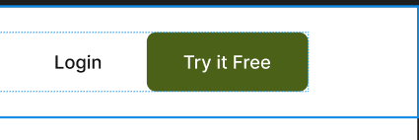
Website: The Navbar(Affects Most Pages)
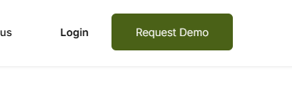
2. Support Email inconsistency: the footer on every page shows support@workmerate.ng.com, but the Privacy Policy, Terms and Conditions, and the Contact Us page BODY all use a different address, support@workmeraterp.com.ng (with an extra "rp"). Two different email addresses are live on the same site
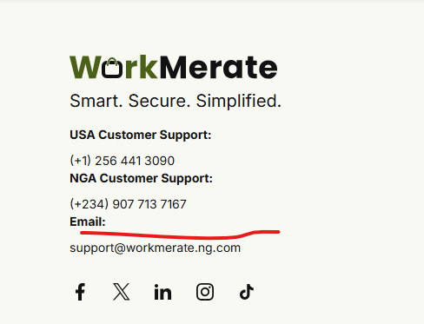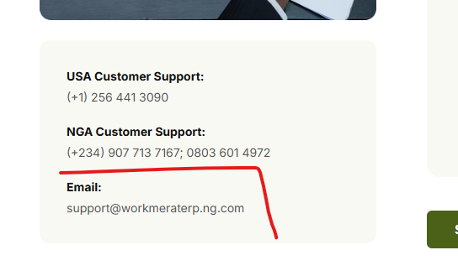

3. Footer Support Number: The second NGA support number hasn't been added. As well as the footer background color discrepancy, the Figma background is darker than the one on the website.
Figma: Website:
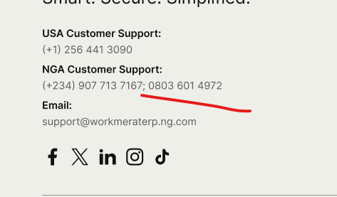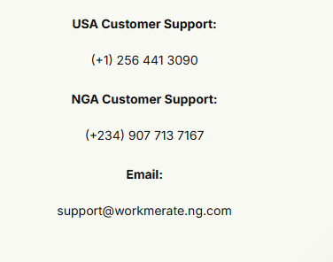

/about
/contact-us
/Pricing
- Confirmed on three-plus screens. Login link on the navbar goes to a 404 Not Found page. Only when clicked on the index page does it route properly.
Issue found: login.html vs. Login.html; this is what is causing the 404
This problem happens on most sign-in links or buttons; worth a general codebase audit. On the signup screen and more(TBD).
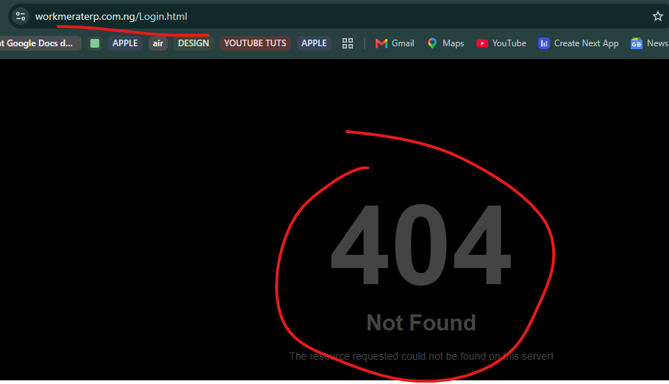

/login
- Issue on this screen. When you click on Sign Up, a get free demo modal is supposed to show up. But doesn’t, and it is unresponsive, making the whole page fixed and unresponsive, so users are not able to navigate to the sign-up screen.
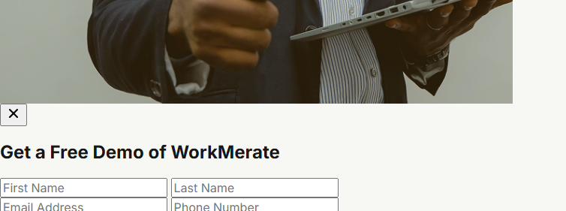

/sign-up
- Apple logo duplicated and sign up text on there.
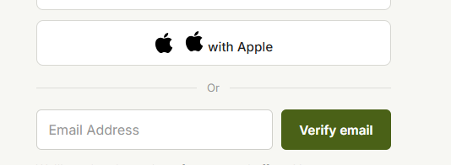

/ privacy-policy:
1. Cookie consent widget is broken; check the cookie policy page as well.
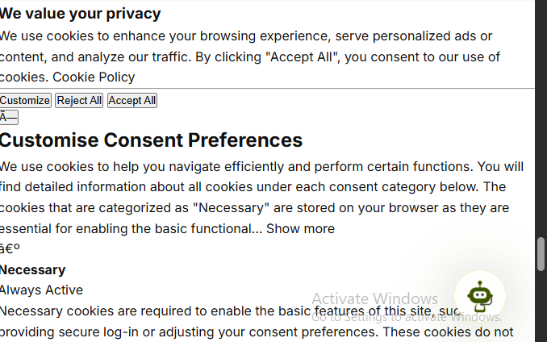

/terms-condition:
1. Social icon links are broken
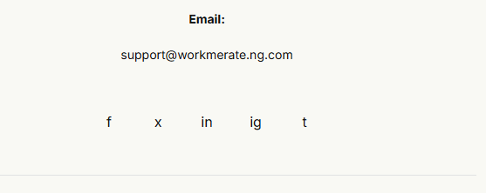

2. Copyright still in 2025
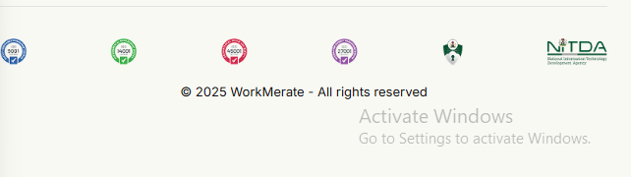

/cookie-policy:
1. Footer: Marketing Automation points to the same page (#)
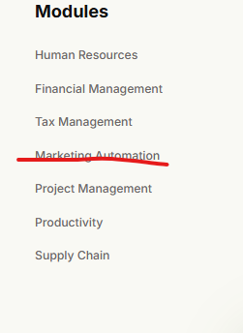

/pricing page:
- Change it to just Annual
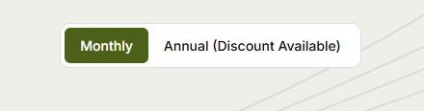
What is on Figma:

- Recheck the font properties of the accordion and ensure it matches what is on Figma
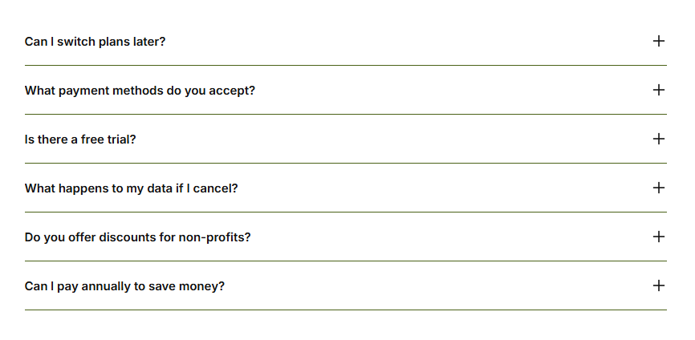

/about page:
- The gradient of the hero section is not the same as what is on Figma.
Figma:

Website:
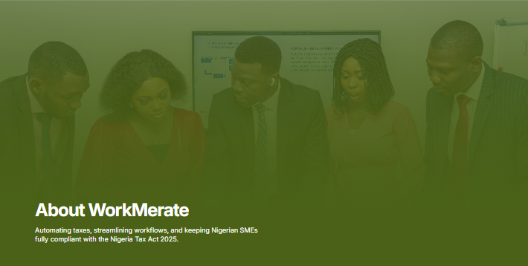

- Tablet View Layout: Needs Adjustment.
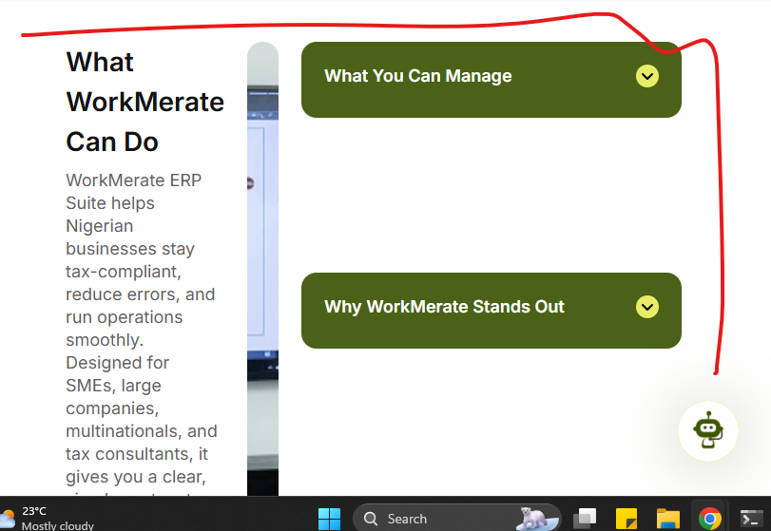
- Responsiveness Issue: CTA Section needs to be checked.
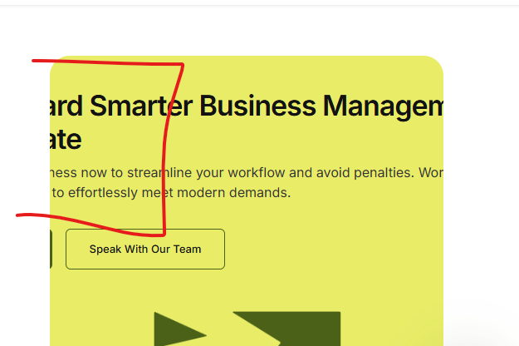

/modules > custom module dev:
1. Footer: Logo doesn't show properly
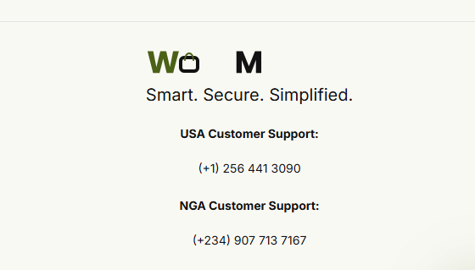
/modules > marketing-automation:
1. Request a demo button leads to the same page (#); the Facebook icon on this same page is also broken (#)
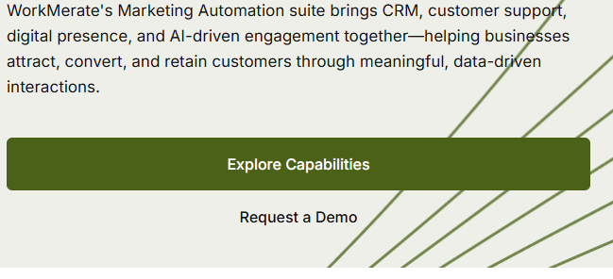
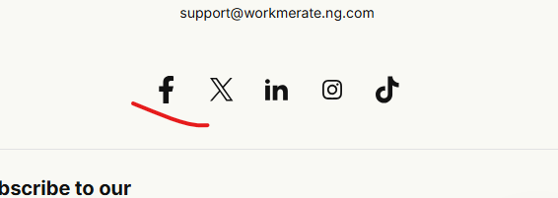

/services > Tax Automation & Compliance:
1. Broken Character
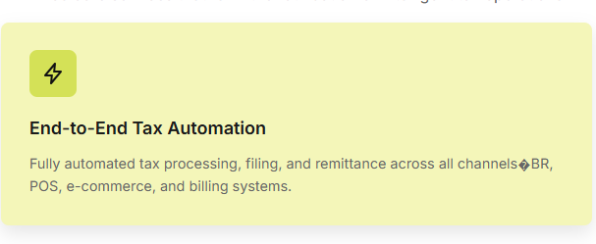

/services > ERP & POS Integrations
1. Wrong Text
Figma:
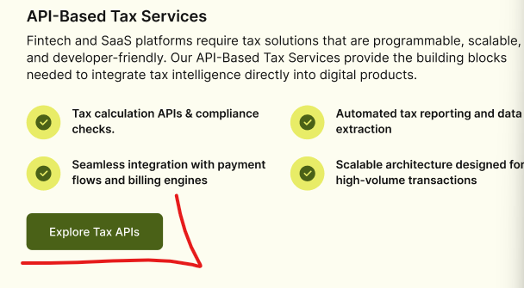
Website:
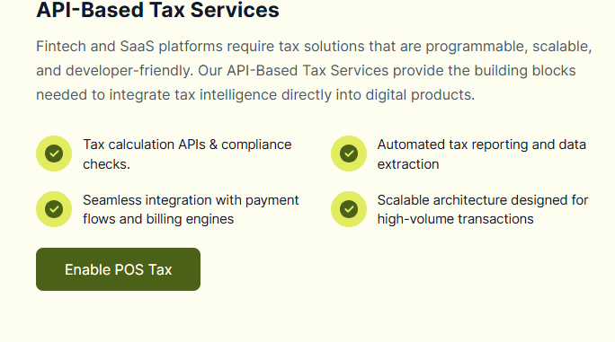

/Services > Advisory & Risk
1. Wrong metadata: the page's browser tab title and meta title both read "Audit & Regulatory Reporting - WorkMerate", the same mislabeling bug found in the Figma(Worth Checking out)
Website:
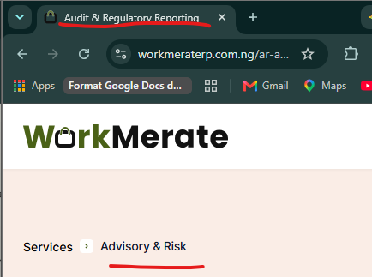

Figma:
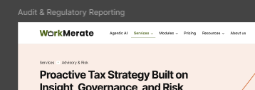

/Resources > Learning.
/Resources > State IRS
/Resources > Tax Calender
/Resources > Tax Laws
- Tablet view: the layout isn’t adjusting properly to most sections of the page. Here are a few examples worth checking out. i.e the text is leaving the screen and component. The same layout issue is happening on the four screens under resources same Hero and CTA text bug, plus other layout mismatches.

